**윈도우즈 프로그래밍**

**컴퓨터공학과**

**20204062 이인규**

**문제 1.**

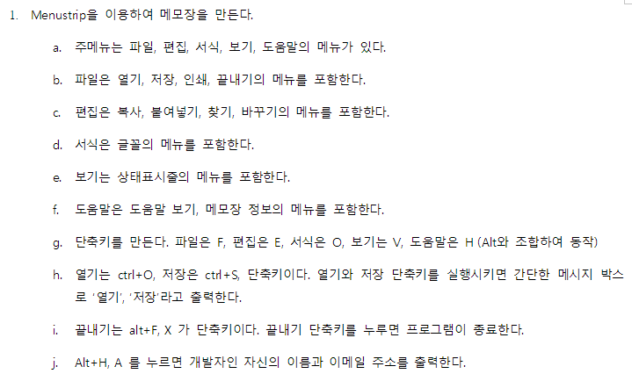

**소스 코드**

|  |
| --- |
| using System;  using System.Collections.Generic;  using System.ComponentModel;  using System.Data;  using System.Drawing;  using System.Linq;  using System.Text;  using System.Threading.Tasks;  using System.Windows.Forms;  namespace WindowsFormsApp5  {  public partial class Form1 : Form  {  public Form1()  {  InitializeComponent();  }  private void 열기ToolStripMenuItem_Click(object sender, EventArgs e)  {  MessageBox.Show("열기");  }  private void 저장ToolStripMenuItem_Click(object sender, EventArgs e)  {  MessageBox.Show("닫기");  }  private void 끝내기ToolStripMenuItem_Click(object sender, EventArgs e)  {  Application.Exit();  }  private void 메모장정보ToolStripMenuItem_Click(object sender, EventArgs e)  {    }  private void 파일FToolStripMenuItem_Click(object sender, EventArgs e)  {  }  private void textBox1_TextChanged(object sender, EventArgs e)  {  }  private void 도움말HToolStripMenuItem_Click(object sender, EventArgs e)  {  }  private void 개발자정보ToolStripMenuItem_Click(object sender, EventArgs e)  {  MessageBox.Show("개발자: LeeInGyu\n이메일: developlee20@gmail.com");  }  }  } |

**실행 결과**

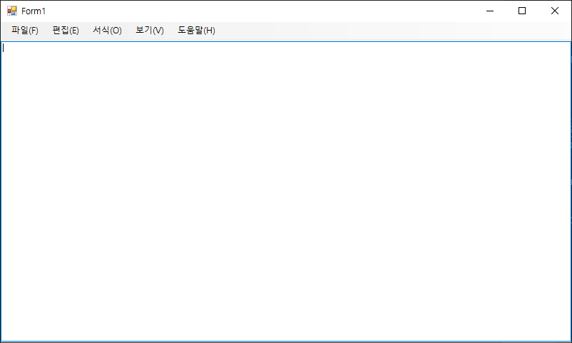

**문제 2.**

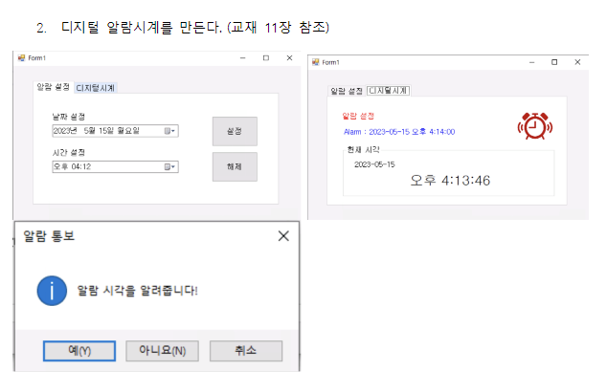

**소스 코드**

|  |
| --- |
| using System;  using System.Collections.Generic;  using System.ComponentModel;  using System.Data;  using System.Drawing;  using System.Linq;  using System.Text;  using System.Threading.Tasks;  using System.Windows.Forms;  namespace WindowsFormsApp6  {  public partial class Form1 : Form  {  private Timer myTimer = new Timer();  private DateTime dDay;  private DateTime tTime;  private bool setAlarm;  public Form1()  {  InitializeComponent();  label4.ForeColor = Color.Gray;  label3.ForeColor = Color.Gray;  dateTimePicker2.Format = DateTimePickerFormat.Custom;  dateTimePicker2.CustomFormat = "tt hh:mm";  myTimer.Interval = 1000;  myTimer.Tick += MyTimer_Tick;  myTimer.Start();  tabControl1.SelectedTab = tabPage2;  }  private void MyTimer_Tick(object sender, EventArgs e)  {  DateTime cTime = DateTime.Now;  label5.Text = cTime.ToShortDateString();  label6.Text = cTime.ToLongTimeString();  if(setAlarm == true)  {  if(dDay == DateTime.Today && cTime.Hour == tTime.Hour && cTime.Minute == tTime.Minute)  {  setAlarm = false;  MessageBox.Show("알람 시각을 알려줍니다!", "알람 통보", MessageBoxButtons.YesNoCancel, MessageBoxIcon.Information);  }  }  }  private void dateTimePicker1_ValueChanged(object sender, EventArgs e)  {  }  private void label1_Click(object sender, EventArgs e)  {  }  private void button1_Click(object sender, EventArgs e)  {  dDay = DateTime.Parse(dateTimePicker1.Text);  tTime = DateTime.Parse(dateTimePicker2.Text);  setAlarm = true;  label3.ForeColor = Color.Red;  label4.ForeColor = Color.Blue;  label4.Text = "Alarm : " + dDay.ToShortDateString() + " " + tTime.ToLongTimeString();  tabControl1.SelectedTab = tabPage2;  }  private void button2_Click(object sender, EventArgs e)  {  setAlarm = false;  label3.ForeColor = Color.Gray;  label4.ForeColor = Color.Green;  label4.Text = "Alarm : ";  tabControl1.SelectedTab = tabPage2;  }  }  } |

**실행 결과**

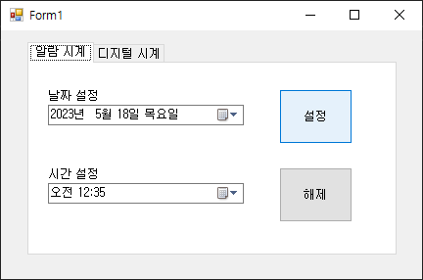

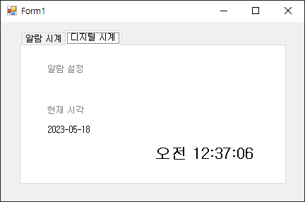

**문제 3.**

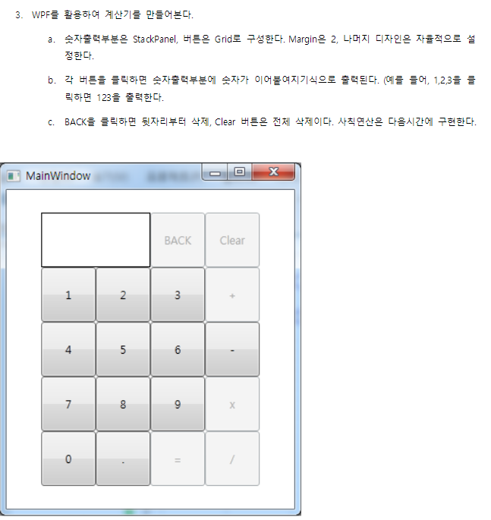

**소스 코드**

|  |
| --- |
| **.xaml** |
| <Window x:Class="WpfApp1.MainWindow"  xmlns="http://schemas.microsoft.com/winfx/2006/xaml/presentation"  xmlns:x="http://schemas.microsoft.com/winfx/2006/xaml"  xmlns:d="http://schemas.microsoft.com/expression/blend/2008"  xmlns:mc="http://schemas.openxmlformats.org/markup-compatibility/2006"  xmlns:local="clr-namespace:WpfApp1"  mc:Ignorable="d"  Title="MainWindow" Height="545" Width="476">  <Grid Margin="30">  <Grid.RowDefinitions>  <RowDefinition/>  <RowDefinition/>  <RowDefinition/>  <RowDefinition/>  <RowDefinition/>  </Grid.RowDefinitions>  <Grid.ColumnDefinitions>  <ColumnDefinition/>  <ColumnDefinition/>  <ColumnDefinition/>  <ColumnDefinition/>  </Grid.ColumnDefinitions>  <StackPanel Grid.Row="0" Grid.Column="0" Grid.ColumnSpan="2" Margin="2" x:Name="panel">  <TextBlock FontSize="50" Margin="10" x:Name="texts"></TextBlock>  </StackPanel>  <Button Grid.Row="0" Grid.Column="2" Margin="2" Click="ButtonBack">BACK</Button>  <Button Grid.Row="0" Grid.Column="3" Margin="2" Click="Button_Click_10">CLEAR</Button>  <Button Grid.Row="1" Grid.Column="0" Margin="2" Click="Button_Click">1</Button>  <Button Grid.Row="1" Grid.Column="1" Margin="2" Click="Button_Click_1">2</Button>  <Button Grid.Row="1" Grid.Column="2" Margin="2" Click="Button_Click_2">3</Button>  <Button Grid.Row="1" Grid.Column="3" Margin="2">+</Button>  <Button Grid.Row="2" Grid.Column="0" Margin="2" Click="Button_Click_3">4</Button>  <Button Grid.Row="2" Grid.Column="1" Margin="2" Click="Button_Click_4">5</Button>  <Button Grid.Row="2" Grid.Column="2" Margin="2" Click="Button_Click_5">6</Button>  <Button Grid.Row="2" Grid.Column="3" Margin="2">-</Button>  <Button Grid.Row="3" Grid.Column="0" Margin="2" Click="Button_Click_6">7</Button>  <Button Grid.Row="3" Grid.Column="1" Margin="2" Click="Button_Click_7">8</Button>  <Button Grid.Row="3" Grid.Column="2" Margin="2" Click="Button_Click_8">9</Button>  <Button Grid.Row="3" Grid.Column="3" Margin="2">X</Button>  <Button Grid.Row="4" Grid.Column="0" Margin="2" Click="Button_Click_9">0</Button>  <Button Grid.Row="4" Grid.Column="1" Margin="2">.</Button>  <Button Grid.Row="4" Grid.Column="2" Margin="2">=</Button>  <Button Grid.Row="4" Grid.Column="3" Margin="2">/</Button>  </Grid>  </Window> |

|  |
| --- |
| **.cs** |
| using System;  using System.Collections.Generic;  using System.Linq;  using System.Text;  using System.Threading.Tasks;  using System.Windows;  using System.Windows.Controls;  using System.Windows.Data;  using System.Windows.Documents;  using System.Windows.Input;  using System.Windows.Media;  using System.Windows.Media.Imaging;  using System.Windows.Navigation;  using System.Windows.Shapes;  namespace WpfApp1  {  /// <summary>  /// MainWindow.xaml에 대한 상호 작용 논리  /// </summary>  public partial class MainWindow : Window  {  public MainWindow()  {  InitializeComponent();  }  private void ButtonBack(object sender, RoutedEventArgs e)  {  texts.Text = texts.Text.Substring(0, texts.Text.Length - 1) + "";  }  private void Button_Click(object sender, RoutedEventArgs e)  {  texts.Text += "1";  }  private void Button_Click_1(object sender, RoutedEventArgs e)  {  texts.Text += "2";  }  private void Button_Click_2(object sender, RoutedEventArgs e)  {  texts.Text += "3";  }  private void Button_Click_3(object sender, RoutedEventArgs e)  {  texts.Text += "4";  }  private void Button_Click_4(object sender, RoutedEventArgs e)  {  texts.Text += "5";  }  private void Button_Click_5(object sender, RoutedEventArgs e)  {  texts.Text += "6";  }  private void Button_Click_6(object sender, RoutedEventArgs e)  {  texts.Text += "7";  }  private void Button_Click_7(object sender, RoutedEventArgs e)  {  texts.Text += "8";  }  private void Button_Click_8(object sender, RoutedEventArgs e)  {  texts.Text += "9";  }  private void Button_Click_9(object sender, RoutedEventArgs e)  {  texts.Text += "0";  }  private void Button_Click_10(object sender, RoutedEventArgs e)  {  texts.Text = "";  }  }  } |

**실행 결과**

